**Department ofComputerScience&Engineering**

## Theory&Concept

##### Objective:-ToimplementtheconceptofJoins

**Joint Multiple Table (Equi Join):**Some times we require to treat more than one table as though manipulate data fromallthe tables as thoughthetables were not separateobject butone single entity. To achieve this we have to join tables.Tables are joinedon column thathave dame data typeand data with in tables.

ThetablesthathavetobejoinedarespecifiedintheFROMclauseandthejoining attributes in the WHERE clause.

AlgorithmforJOINinSQL:

* 1. Cartesianproductoftables(specifiedinthe FROMclause)
  2. Selectionofrowsthatmatch(predicateintheWHEREclause)
  3. Projectcolumnspecified intheSELECTclause.

1. Cartesianproduct:-

Considertwotablestudentandcourse Select B.*,P.*

FROMstudentB,courseP;

1. INNERJOIN:

Cartesianproductfollowedbyselection Select B.*,P.*

FROM student B, Course P WHEREB.course#P.course#;

1. LEFTOUTERJOIN:

LEFTOUTERJOIN=Cartesianproduct+selectionbut includerowsfromthe lefttable which are unmatched pat nulls in the values of attributes belonging to th e second table

Exam:

SelectB.*,P*

FROMstudentBleft joincoursep ON B.course # P.course #;

1. RIGHTOUTER JOIN:

RIGHTOUTERJOIN=Cartesianproduct+selectionbut includerowsfromrighttable which are unmatched

Exam:

SelectB.*,P.*FromstudentBRIGHTJOINcourseP B.course# = P course # ;

1. FULLOUTER JOIN

Exam

Select B.*,P.*

Fromstudent BFULLJOINcourseP On B.course # = P course # ;

## EXPERIMENTNO.5

**A.ConsiderthefollowingschemaforaLibraryDatabase: BOOK (*Book_id, Title, Publisher_Name, Pub_Year*) BOOK_AUTHORS (Book_id, Author_*Name*)**

**PUBLISHER (*Name, Address, Phone*) BOOK_COPIES(*Book_id,Branch_id,No-of_Copies*)**

**BOOK_LENDING(*Book_id,Branch_id,Card_No,Date_Out,Due_Date*) LIBRARY_BRANCH (*Branch_id, Branch_Name, Address*)**

**WriteSQLqueriesto:**

1. Retrieve details of all books in the library– id, title, name of publisher, authors, number of copies in each branch, etc.

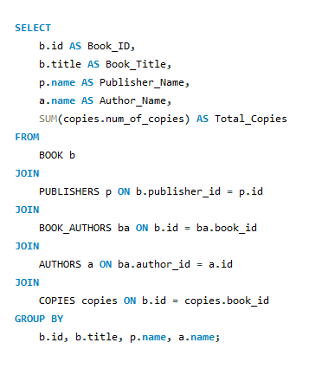

1. Get the particulars of borrowers who have borrowed more than 3 books, but from Jan 2017 to Jun 2017.

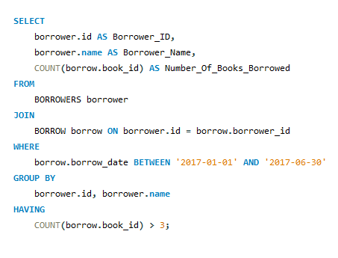

1. Delete a book in BOOK table. Update the contents of other tables to reflect this data manipulation operation.

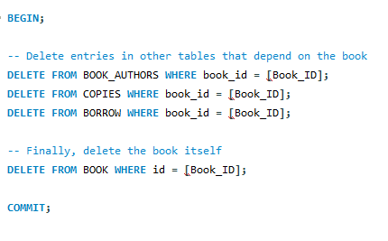

1. 4.Partition the BOOK table based on year of publication.Demonstrate its working with a simple query.

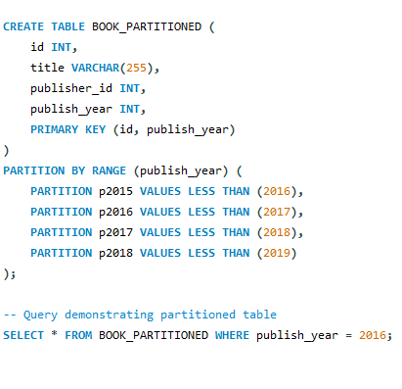

1. Create a view of all book sand its number of copies that are currently available in the Library.

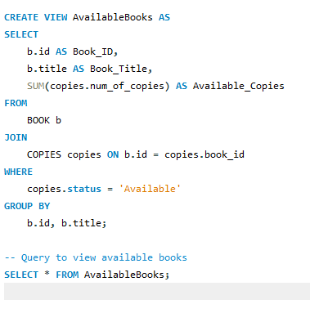

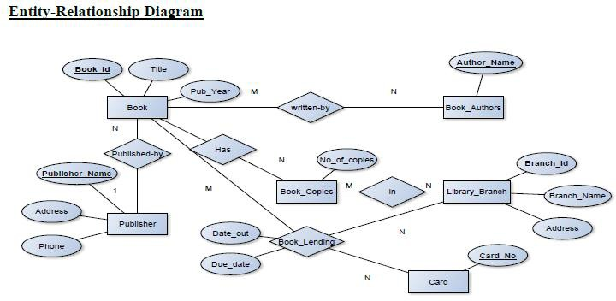

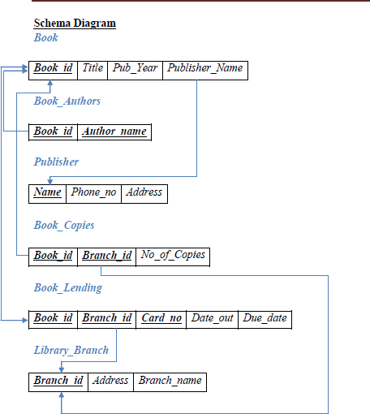

**TableCreation**

CREATETABLEPUBLISHER (

NAMEVARCHAR2(20)PRIMARYKEY, PHONE INTEGER,

ADDRESSVARCHAR2 (20)

);

CREATETABLEBOOK (

BOOK_IDINTEGERPRIMARYKEY, TITLE VARCHAR2 (20),

PUB_YEARVARCHAR2(20),

PUBLISHER_NAMEREFERENCESPUBLISHER(NAME)ONDELETECASCADE

);

CREATETABLEBOOK_AUTHORS (

AUTHOR_NAMEVARCHAR2(20),

BOOK_IDREFERENCESBOOK(BOOK_ID)ONDELETECASCADE, PRIMARY KEY (BOOK_ID, AUTHOR_NAME)

);

CREATETABLELIBRARY_BRANCH (

BRANCH_IDINTEGERPRIMARYKEY, BRANCH_NAME VARCHAR2 (50),

ADDRESSVARCHAR2 (50)

);

CREATETABLEBOOK_COPIES (

NO_OF_COPIESINTEGER,

BOOK_IDREFERENCESBOOK(BOOK_ID)ONDELETECASCADE,

BRANCH_IDREFERENCESLIBRARY_BRANCH(BRANCH_ID)ONDELETECASCADE, PRIMARY KEY (BOOK_ID, BRANCH_ID)

);

CREATETABLECARD (

CARD_NOINTEGERPRIMARY KEY

);

CREATETABLEBOOK_LENDING (

DATE_OUTDATE, DUE_DATEDATE,

BOOK_IDREFERENCESBOOK(BOOK_ID)ONDELETECASCADE,

BRANCH_IDREFERENCESLIBRARY_BRANCH(BRANCH_ID)ONDELETECASCADE, CARD_NO REFERENCES CARD (CARD_NO) ON DELETE CASCADE,

PRIMARYKEY(BOOK_ID,BRANCH_ID,CARD_NO)

);

**InsertionofValuesto Tables**

INSERTINTOPUBLISHERVALUES(‗MCGRAW-HILL‘,9989076587,‗BANGALORE‘); INSERT INTO PUBLISHER VALUES (‗PEARSON‘, 9889076565, ‗NEWDELHI‘);

INSERT INTO PUBLISHER VALUES (‗RANDOM HOUSE‘, 7455679345, ‗HYDRABAD‘); INSERT INTO PUBLISHER VALUES (‗HACHETTE LIVRE‘, 8970862340, ‗CHENAI‘); INSERTINTOPUBLISHERVALUES(‗GRUPOPLANETA‘,7756120238,‗BANGALORE‘);

INSERT INTO BOOK VALUES (1,‘DBMS‘,‘JAN-2017‘, ‗MCGRAW-HILL‘); INSERTINTOBOOKVALUES(2,‘ADBMS‘,‘JUN-2016‘,‗MCGRAW-HILL‘); INSERT INTO BOOK VALUES (3,‘CN‘,‘SEP-2016‘, ‗PEARSON‘);

INSERTINTOBOOKVALUES(4,‘CG‘,‘SEP-2015‘,‗GRUPOPLANETA‘); INSERT INTO BOOK VALUES (5,‘OS‘,‘MAY-2016‘, ‗PEARSON‘); INSERT INTO BOOK_AUTHORS VALUES (‘NAVATHE‘, 1);

INSERT INTO BOOK_AUTHORS VALUES (‘NAVATHE‘, 2); INSERT INTO BOOK_AUTHORS VALUES (‘TANENBAUM‘, 3); INSERTINTOBOOK_AUTHORSVALUES(‘EDWARDANGEL‘,4); INSERT INTO BOOK_AUTHORS VALUES (‘GALVIN‘, 5);

INSERTINTOLIBRARY_BRANCHVALUES(10,‘RRNAGAR‘,‘BANGALORE‘); INSERT INTO LIBRARY_BRANCH VALUES (11,‘RNSIT‘,‘BANGALORE‘);

INSERTINTOLIBRARY_BRANCHVALUES(12,‘RAJAJINAGAR‘,‘BANGALORE‘); INSERT INTO LIBRARY_BRANCH VALUES (13,‘NITTE‘,‘MANGALORE‘);

INSERTINTOLIBRARY_BRANCHVALUES(14,‘MANIPAL‘,‘UDUPI‘);

INSERTINTOBOOK_COPIESVALUES(10,1,10);

INSERTINTOBOOK_COPIESVALUES(5,1,11);

INSERTINTOBOOK_COPIESVALUES(2,2,12);

INSERTINTOBOOK_COPIESVALUES(5,2,13);

INSERTINTOBOOK_COPIESVALUES(7,3,14);

INSERTINTOBOOK_COPIESVALUES(1,5,10);

INSERTINTOBOOK_COPIESVALUES(3,4,11);

INSERTINTOCARDVALUES(100); INSERTINTOCARDVALUES(101); INSERTINTOCARDVALUES(102); INSERTINTOCARDVALUES(103); INSERTINTOCARDVALUES(104);

INSERTINTOBOOK_LENDINGVALUES(‘01-JAN-17‘,‘01-JUN-17‘,1,10,101);

INSERTINTOBOOK_LENDINGVALUES(‘11-JAN-17‘,‘11-MAR-17‘,3,14,101);

INSERTINTOBOOK_LENDINGVALUES(‘21-FEB-17‘,‘21-APR-17‘,2,13,101);

INSERTINTOBOOK_LENDINGVALUES(‘15-MAR-17‘,‘15-JUL-17‘,4,11,101);

INSERTINTOBOOK_LENDINGVALUES(‗12-APR-17‘,‘12-MAY-17‘,1,11,104);

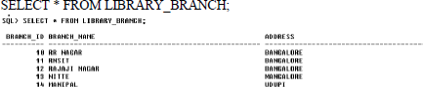

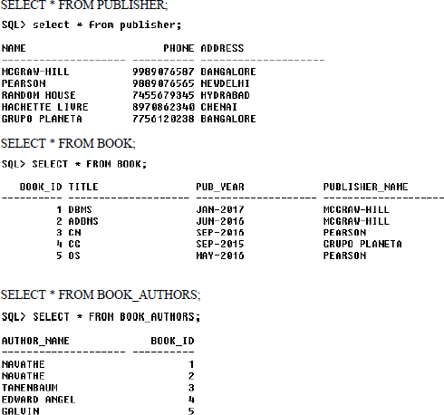

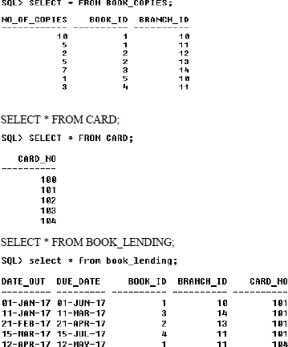

**Queries:**

1. **Retrievedetailsofallbooksinthelibrary –id,title,nameofpublisher,authors,numberofcopies in each branch, etc.**

SELECTB.BOOK_ID,B.TITLE,B.PUBLISHER_NAME,A.AUTHOR_NAME,C.NO_OF_COPIES, L.BRANCH_ID

FROMBOOKB,BOOK_AUTHORSA,BOOK_COPIESC,LIBRARY_BRANCHL WHERE B.BOOK_ID=A.BOOK_ID

ANDB.BOOK_ID=C.BOOK_IDAND L.BRANCH_ID=C.BRANCH_ID;

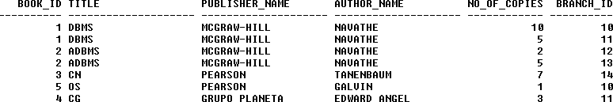

1. **Gettheparticularsofborrowers who haveborrowedmorethan3books,butfrom Jan2017to Jun 2017.**

SELECTCARD_NOFROM BOOK_LENDING

WHEREDATE_OUTBETWEEN‘01-JAN-2017‘AND‘01-JUL-2017‘ GROUP BY CARD_NOHAVING COUNT (*)>3;



1. **DeleteabookinBOOK table.Updatethecontentsofothertablestoreflectthisdata manipulation operation.**

DELETEFROMBOOK WHERE BOOK_ID=3;

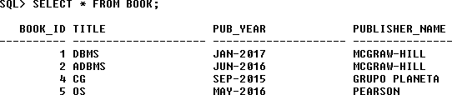

1. **PartitiontheBOOK tablebasedonyearofpublication.Demonstrateitsworking withasimple query.**

CREATEVIEWV_PUBLICATIONASSELECTPUB_YEARFROMBOOK;

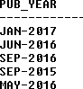

1. **Createaviewofallbooksand itsnumberofcopies thatarecurrentlyavailableintheLibrary.**

CREATEVIEWV_BOOKSASSELECTB.BOOK_ID,B.TITLE,C.NO_OF_COPIES FROM BOOK B, BOOK_COPIES C, LIBRARY_BRANCH L

WHEREB.BOOK_ID=C.BOOK_IDAND C.BRANCH_ID=L.BRANCH_ID;

